- Chapter 1
  - intro
    - 2 ways to change performance
      - Change inefficient algorithm to efficient x10-x100
      - Poor implementation to good one x2-x
    - Can over complicate code for simple inputs and be prone to more error
  - Sorting
    - Tradeoffs of different software
      - Good algorithms harder to implement than poorer ones
      - Best-worst-average case behavior of algorithms
      - Different implementation characteristics
  - Sorted order
    - Not efficient to move all data down to add one record if records are numberous
  - Indexing
    - Sorting an efficient way ex- by zip code for usps
    - Ex – receipts need to be stored numerously but not really accessed
    - Ex – routers - accessed constantly/ordered constantly but never used again
  - Dynamic vs static
    - Questions to ask
      - Size of data objects
      - Size of object relative to ongoing change to object
      - What happens to data item when deleted
    - What is the needed access/storing methods
  - Memory/bandwidth
    - Mobiles that are limited in memory/bandwidth and need programs that adapt to this
    - Ex – a program that downloads pictures all at once then the user never needs to download again when using the program but waits for a while the first time around or looks at pictures and they download in the background before the next one is shown
  - Heuristics
    - Incremental updates – update every so often instead of sorting all data every time only one data is added
    - Not efficient to use complicated algorithm for non critical and rarely used function – attack most critical/important functions first
  - Templates/generics
    - Flat file contains records (rows)and each record has a field –(column )
    - These items make exists as all type of data types and sorting needs to be independent of what type of file it is sorting
    - Using trees – such as folders to sub categorize data
    - Ex – library data – data of books is static but check in/out is constantly changing
    - Standard used – ex card catalogs to keep all data organized
  - Student records
    - Classic example – name, id number, etc are going to be static
    - Address/major/etc might need updating rarely
    - Transcript info is different – needs massive updating 2x a year but only to add data and not change – usually need access as well
  - Retail transactions
    - Retailers that store massive data constantly and need constant indexing/ retrieval for large data but may rarely be needing accessing
  - Packet info
    - Internet packets – fixed size and are unique each time
    - Need to be broken up and transferred to unique destination
    - Be able to put back together from random order of receiving
    - As well as redownload corrupt data
    - They are discarded fast and are persistently changing
  - Process queues
    - Dozens of processes in state of execution and need to be prioritized on the fly
    - Data structure needs to be highly dynamic and easily changed
  - Google
    - Data mining a missive amount of info that is changing and may contain errors
    - Being able to sort through data to find relevant info and access in fast way
  - Game tress ex chess
    - Computing involving optimizing an objective function – chess – determine which moves maximize function – needs to reevaluate at each player’s move
    - May be an large number of possibilities so you limit number of decisions explored
  - Phylogenetic
    - Biology that computes backwards through time from a list of current species to determine best possible evolutionary tree back to common ancestors
    - The number of possible paths are huge and must be efficiently handled with algorithms
  - Summary
    - Java collections framework – almost all data structures exist in the jfc

- Chapter 2 –review of java
  - Basic data payload class
    - Record class that handles data payload
    - Declare instance variables and static variables (no matter how many instances of that class there are, there is only one of that static variable)
    - Assign dummy values for all instance variables
    - Use encapsulation – limit as much as possible the exposure outside the class of information about variables
    - Do file handling in the main program
    - toString method created in data payload class to tosTRing all data but the class will not know what will be done with the string data
    - use compare to method to compare data inside class so other classes don’t need to know data being compared
  - the main program
    - will be used to:
      - setup program for input and output by prompting or open/close files and checking files/names/ etc are valid
      - invoke method that “doesthework”
    - keep it simple so details can be encapsulated
    - three basic classes
      - the driver – main program –handles in/out put
      - at bottom is data payload class – contains variables, accessor / mutator methods, method to read entire record, toString and sometimes comparison methods
      - helper methods in between that converts the raw data into parsed data
      - actual handling of files will be used by fileUtils method to clean up code and only use it once- only needing to make sure its correct once
  - comments about style and docs
    - good practice to put copyright in code
    - should maintain audit log of when code was updated
    - group methods by type then name
      - accessor/mutator first appearing together for each instance variable then the general methods
    - use “this” keyword to identify variables that are used in the entire class
    - comment closing brackets what they are closing
    - put class label in class definition – in sysout so that if error then you can see what class is doing that error in the cmd prompt
    - cannot nest slash-star-star comments ex - /********
        - can nest slash-slash-star comments ex - //*******
  - java docs
    - can auto print out standard documentation
    - use <code> </code> @param @return tags for doc
      - initial sentence triggers response in doc creation – end of first period
  - uml
    - short hand notation of instance variables, methods, return, parameters, public/private headings
    - section 1 is class name
    - next section is varaibles with + or – to indicate public/private
    - last section is methods with + or -, the name of method, parameters, then the return value (int or void, etc)

- Chapter 3 –flat files
  - Basic indexed file
  - Basic program
    - Four basic parts
      - The data payload
        - Lowest level – set of payload records that contain actual data
        - All instance variables and methods to handle data will be in this class
        - Idea is for any higher level classes able to work with this data without knowing what’s going on with it
      - The data structure class
        - Next level up – instance variables/methods to manage data structure
      - The user application
        - Will contain code implementing features of app
          - Such as add/contains/remove records
          - Only needs to know to add/remove/contain records but not what they are or what happens
      - The main program/driver
        - Will normally do three things
          - Open files for input and output
          - Create instance of application class to perform tasks and test classes below it
          - Clean up after test and terminate program
    - Always write code to be portable – can be used in all types of applications
  - The record code
    - Handles everything connected with a single record and individual fields inside that record
    - Comparison methods usually return -1, 0, or +1 if first string is less/equal/more than second
    - Can create multiple compareto methods to compare by different values
  - Driver for app
  - Original flatfile code
    - The data structure class –
  - Analysis of the code
  - Sorted data
    - 2 choices when presented with unsorted data
      - Can read and physically move records into order
        - Only acceptable if
          - Don’t have a lot of data to move
          - Record are to be accessed in only one order
          - If data will be fairly static – don’t want to keep moving things when adding/removing
        - Problems are
          - Moving data each add/remove
          - If removing need to shift everything down one index
      - Can use indexes to order data without actually moving it
        - Read the record placement into an array and organize the array
        - Make an indirect reference to record – don’t actually access record but rather read subscript
        - 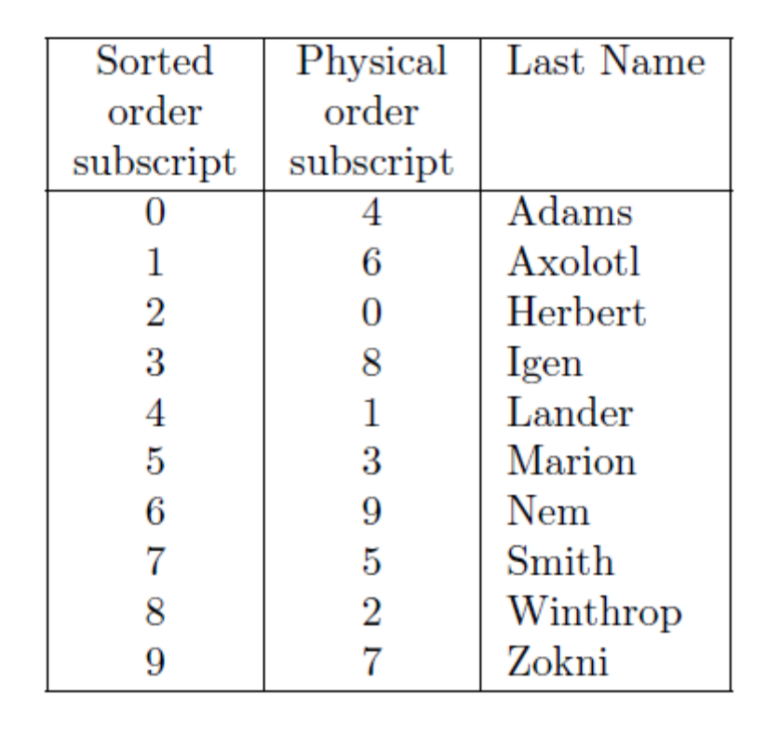
    - Simple but inefficient sorting
      - Bubble sort – using array list
      - Contains a doubly nested loop
      - 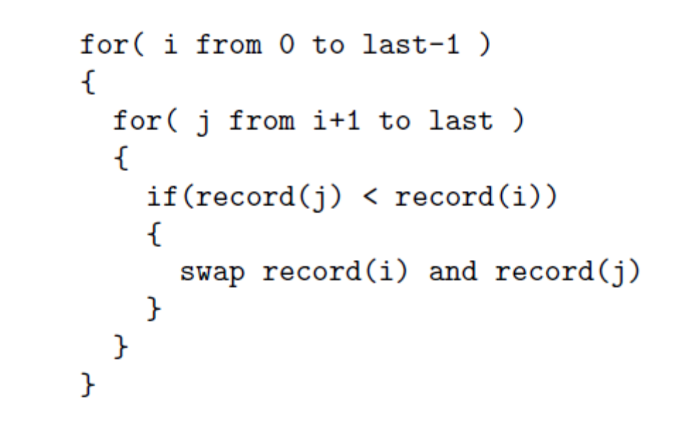
      - Sorting keys instead of the actual data
      - Cant sort data in more than one way and need arraylist for each sorting organization
  - Searching through a list
    - Linear search – walks through each data to search for item
    - On average you look half way down list before finding what you want assuming list is sorted
  - Foreshadowing of things to come
    - Linear search and bubble sort is okay for small amount of data but not large
    - Use dynamic data structures that permit efficient insertion/deletion
    - Information hiding needed so that each class doesn’t know what the other is doing
  - Effective sorting techniques
    - Bubble sort requires N^2 times comparisons to sort
    - Any sort that works needs at least NlogN comparisons
    - Bubble sort only needs one extra space but merge sort needs N/2 space
    - Space and time are considered in sorting but time more than space – can’t take time back and space is usually plentiful
  - Effective search techniques and data structures for priority
    - Binary search and recursive divide and conquer
      - Divide and conquer – cut the size of the problem in half at each stage
      - Begin in binary search with list of N lists
      - Cut list in half and discard ½ that is not needed in search
      - Continue this pattern until the item is found
      - Can be done in 2^n time

  - Static vs dynamic storage structures
    - Two problems takes different kinds of data structures
    - Not worth to sort if takes an hour and an item is added every hour
    - On other hand, if only adding once a week then it’s worth the sort
  - Generics and abstract classes
    - Allows common methods to handle different data types
    - Permits programmer to define templates and general purpose methods with data objects that are not specified at compile time
  - Array vs arraylists
    - Array list simpler construct to use for one dimensional lists with size being unknown
    - Storage for arraylist is done dynamically with no preallocation needed and no out of space errors from allocating too little space
    - Size method determines how many actual indexes are being used instead of giving whole array size
    - Remove method does a list compression automatically to remove hole caused by remove
  - Binary search – first mature algorithm
    - If paid price of initially sorting data then binary search is most natural to use
    - Compares k (the key) to the middle item and discards the half not needed in the search – continues to split in half until item found
    - Hard part is getting the concept of half way – if even/odd number of items
    - Will take at most long(2)N probes to search

- Chapter 4 – array and linked lists
  - Array and arraylists
    - On main advantage of array/array list is can perform random access to retrieve particular data record
    - Can directly access the i-th index of the arraylist
    - Linked list doesn’t have this feature
    - Negative aspects of array
      - Require a static allocation of space
        - Cant add more records after preallocated number of spaces
        - Might over allocate and waste space or underallocate and run out of space
      - Arrays only provide linear look at data indexed item by item
        - Can only sort data by one way ex – by name but then cant do it by number
      - Length – method return s the length of the array and not how many indexes are being used – returns used and used number
    - Array list solves many of these problems
      - Part of collections classes in java
      - Can add items without needing to specify set length of arraylist
      - Array provide less security than arraylist – array list makes it harder to cause silly mistakes
      - Common error would be trying to access out-of-bounds index
    - Array list is really a wrapper of an array – adds more allocation if needed automatically and has indexes as well
  - Linked lists
    - A head points to the first element in a list – a node
    - The last element points to a tail indicating the last node
    - The search starts at the head and goes down the linked list until it reaches the tail which indicates null or the end of the list
  - Linked lists and pointers
    - The power of linked list comes from being able to store data of variable and changing sizes
    - Each box is a node that carries data in it – each box is a class object of node
    - Doubly linked list is the same only instead of only going from head to tail you can go from tail to head as well – are able to go back and forth in list by using next and prev methods
    - 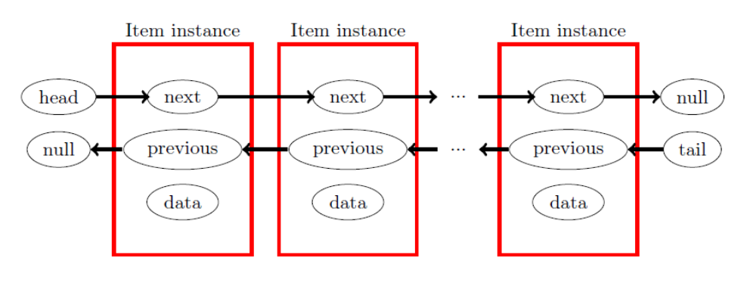
    - Three characteristics
      - Dllnode has an abstract data type or ADT for a node in a linked list
        - Class will not have actual variables that hold data – used by record class
      - Placeholder for constructor – how to create nodes and how to deal with initial conditions
      - Doubly linked list – more memory but can go back and forth
  - Linked list class
    - Driver creates dll and invokes “dothework” method from dll object
    - Methods addathead, linkafter, unlink to operate on nodes
    - Linkafter, setnext, setprev are private operations of nodes
    - Value of size starts at 2 – the head and tail count in size but are null
    - Order of adding a node
      - Point newnode next to nextnode
      - Point newnode prev to prev node
      - Point nextnode to newnode then prevnode to newnode
  - Linked lists with head/tail nodes
    - Can be usful to have info in head/tail such as max/min int values to compare newnode with int value and head will always be max and tail always be min
  - Exception handling
    - Needed to handle errors – ex – variables not being set in a class then trying to be accessed in another class
    - Unlink/remove – don’t allow unlink or deletion of head/tail nodes
  - Linked lists using arrays
    - 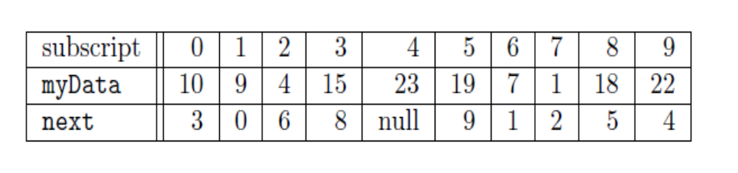
    - Creating arrays to index the next index of the data list
  - Array, arraylists, free list
    - Linked list is dynamic –
    - Adding on more index to arraylist doubles the size – predetermined length as well
  - Insertion sort
    - If sorted list – and only one entry to add – then insert sort is good
    - Walk through list until we find location to insert – then insert at that point
    - Usually done by adding element to end then pulling it forward to location – less data to move
    - 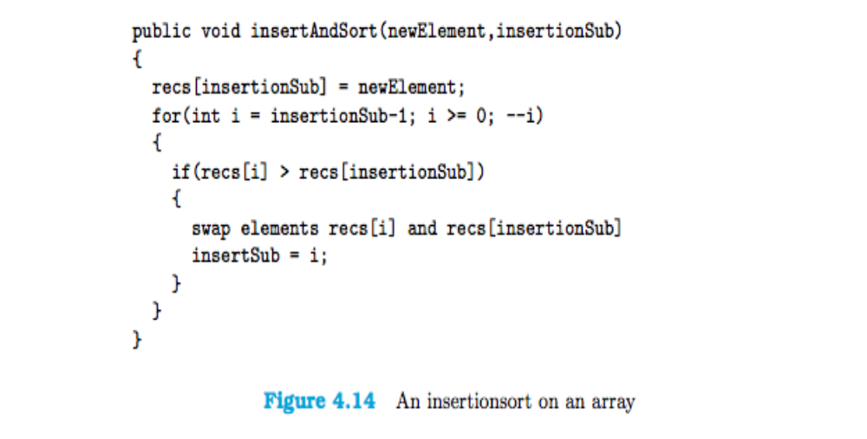
    - Not efficient b/c requires on average half existing list be traveled through

- Chapter 5 – generics, collections, testing
  - Create data payload itself as a variable – generic type
    - The compiler must know that methods invoked are always going to exist for generics
    - Often compareTo or equals methods are for this purpose
    - Use implements to guarantee that methods will be there
    - T is used for generics – use type T instead of type you want to replace
    - When creating instance of the generic class – specify the data type wanted
      - Ex – ArrayList<record> myList
    - The comparable interface is used to override the compareTo method
  - Linked list
    - Has methods for add, contains, and remove
  - Iterators
    - A class that implements two or more methods for accessing the elements of a data structure
    - Next and hasnext methods need to be implemented – doesn’t require remove to be implemented
    - Listiterator requires more methods to be implemented
    - Track data – not the object that contains the data – instead of fetching the data structure element and then the data – we fetch the data element directly and can ignore the implementations below
  - Junit
    - Allows for unit testing of programs
    - Individual code modules can be tested and used to ensure all lines of code have be executed before delivery
    - Testing of code, exceptions, etc.
    - Junit requires the jar file in eclipse
    - Will need tester class – green for successful, red for failure with locations of failure pointed out
    - Tester class that executes code, assigns variable values, etc – assert what should be true
    - Requires writing correctly for actual code and correctly for testing code as well

- Chapter 6
  - Need to find how much better are algorithms and what is worst case scenarios
  - What is log?
    - Natural log – ln(x) = log(e)x
    - Common log – log(10)x = lnx/ln10
    - Binary log – log(2)x = lnx/ln2
  - Comparing algorithms
    - Binary is about lgN comparisons
    - Linear is about N comparisons
    - LHopitals rule as limit of N reaches infinity then 1/N = 0
      - N gets bigger and bigger so the fraction gets smaller and smaller until essentially reaching zero
  - Asymptotic notation
    - f(x) = O(g(x))
    - if there exists constants c and C such that x > c |f(x)| <= C * g(x)
    - binary vs linear search that lgN = O(N)
  - sloppiness
    - measures are almost always positive so we can exclude the | | symbols
  - basic orders
    - O(lgN) = cost of binary search
    - O(N) = cost of single loop running 1 to N
    - O(N^2) = cost of doubly nested loop – ex bubblesort
    - O(N^3) = nested triple for loop
    - O(2^N) = running time – exponential time
    - O(N^N) = even worse exponential running time
  - Theorems
    - For any fixed constant K, any function KF(N) is big Oh of F(N).
    - If f(x) = O(g(x)), and if limx!1 f(x) = 1, then f(x)+K = O(g(x)) for any constant K.
    - If f(x) = O(g(x)) and g(x) = O(h(x)), then f(x) = O(h(x)).
    - For any fixed base a, the function logaN is O(lgN).
    - Let f(x) = a(k)x^k + a(k-1)x^(k-1) + ... + a(1)x + a(0) be a polynomial of degree k then f(x) is O(x^k).
    - 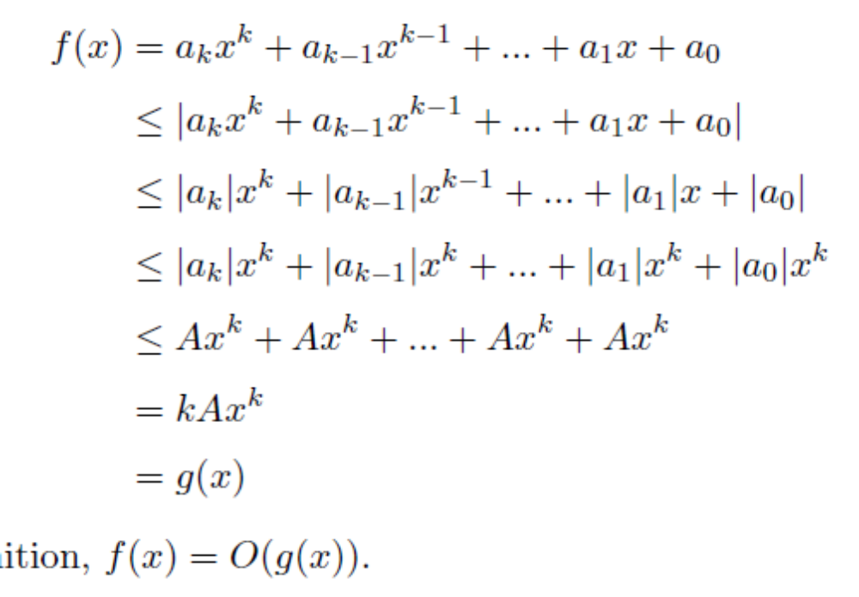

  - Costs of work
    - Each look of N costs you at least 1 – so total cost of looking at N has to be at least N which goes to infinity
    - Big oh is less than or equal to
    - Little oh is genuinely less than
      - Meaning the size of f(x) becomes smaller compared to g(x) as x gets larger – all the way to infinity and f(x) is zero compared to g(x)
    - If we have f(x) = o(g(x)) and g(x) is a positive function everywhere, then we have f(x) = O(g(x)).
    - 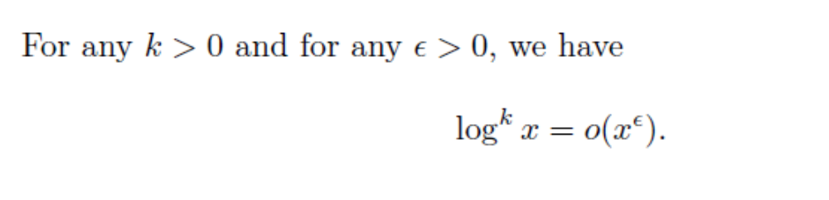
    - 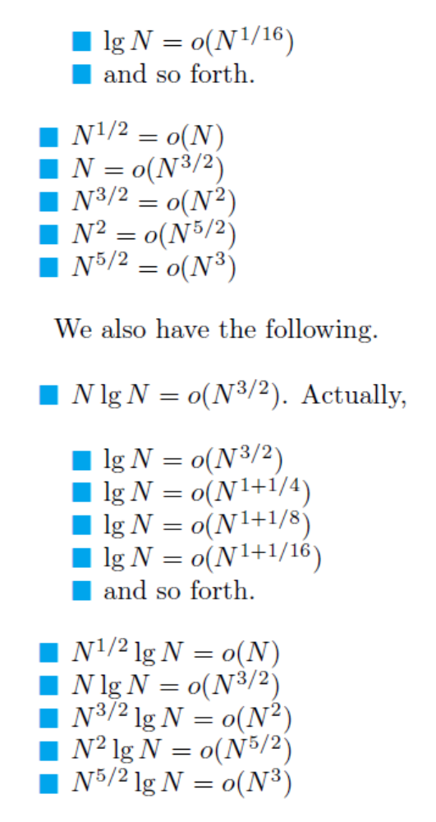
    - 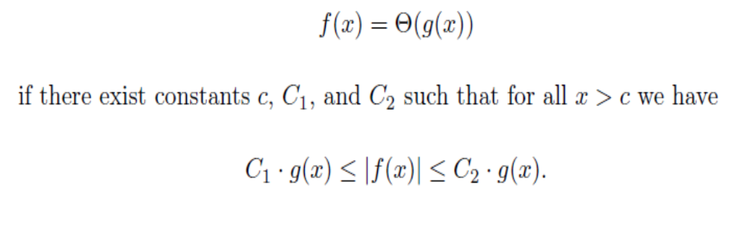
    - 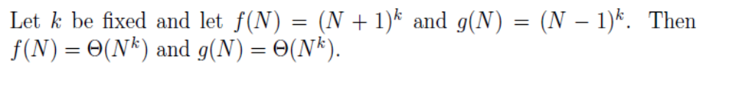
    - 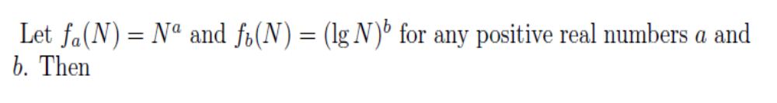
    - 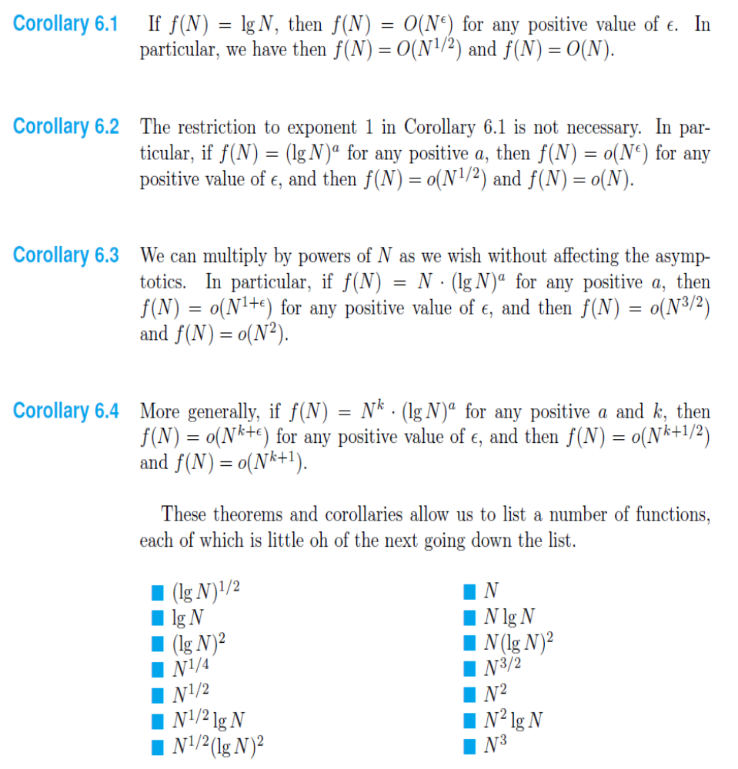
    - Comparing 2 integers is constant time
    - Comparing 2 string of fixed max length is constant time
    - Comparing 2 string of arbitrary length is not constant time

  - Big omega
    - Greater/equal to
    - 
     